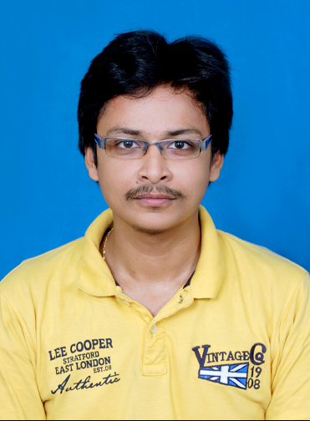
CHITTOORI SATISH
Postal Address : 26-24-20/1, Velampeta,
Town Kotha Road,
Visakhapatnam-530 001.
E-mail : chitturi.satishmd@gmail.com
Mobile : +91 9177000877

SPECIAL ACHIEVEMENTS
- I have trained Siluguri Branch Team for ALIGN PROCESS (8 Projects) in the period of Aug’ 2013 to Aug’ 2015 for 2 Years.
- On behalf of my Hard Work, Performance, Dedication and Punctuality I was rewarded as a TRUE ACCLARIAN Award of the year 2014.
- I am a member of CSR Committee (Corporate Social Responsibility) and our team was awarded with Best Committee among Cultural and Sports for the year 2014.

PROFESSIONAL PRESENTATION
EMPLOYER | TENURE | DESIGNATION | LOCATION
Acclaris Business Solutions Pvt. Ltd. (A Willis Towers Watson Company) | Feb 07 2011 to till date | *PROCESS LEAD* Operations. | Visakhapatnam
- I am one of the Process Lead among 4, we are leading a team size of 55, different processes from three different clients.
Throughout my career,
- I had worked for Client HES, My Matrixx and Align Networks.

ROLES & RESPONSIBILITIES
- Monitor Operations across centers, one is in Visakhapatnam and second is in Siliguri (West Bengal).
  - Ensure operations are going to meet daily deliverables.
- Define and set process controls based on the feedback from Quality improvement team and clients.
- Drive New & Refresher Trainings
  - Look out necessity of Refresher training whenever we observe knowledge gaps or process updates.
- Performance reviews and identify areas of improvement.
  - Review daily, weekly and monthly performance reports, assisting low performer to SME and TLs to drive them.

LANGUAGES
I Can Speak : English Telugu Hindi
I Can Write : English Telugu
I Can Read : English Telugu Hindi
ACADEMIC QUALIFICATION
B.Com (Commerce) | 2008-2011 | Visakhapatnam
M.B.A (Banking and Finance) | 2011-2013 | Visakhapatnam

ADDITIONAL QUALIFICATION
Typewriting  English 70 WPM,  Telugu 50 WPM (Apple Keyboard) | Kesava Institute | 2003-2004 | Visakhapatnam
Diploma In  Advanced Desktop Publishing | Datapro Infoworld Ltd. | 2005-2006 | Visakhapatnam
Diploma in  Computer Management | Datapro Infoworld Ltd. | 2006-2007 | Visakhapatnam

PERSONAL PROFILE
Date of Birth : 14/05/1987
Contact : +91 9177000877
Gender : Male

I am hoping to receive a favorable reply.
Thanking You,

Date :
Place : VISAKHAPATNAM (CHITTOORI SATISH)

